**Activity Response**

I will be attaching the responses of all the tasks given to me, below-

**Vendor Performance Evaluation-**

Provided the suitable rankings to the vendors after analyzing the overall performance. It can be viewed from the sheet named “ranking” in the excel file attached in the mail.

Observations-

* BPO 9 is ranked best as its overall performance was best amongst all, exhibiting a well- balanced combination of low operational costs, high revenue efficiency and optimal utilization of the workforce.
* Other top rankings are grabbed by BPO 6 and BPO 10 excelling in cost- efficiency and maintaining good talk time metrics.
* The lowest performers include BPO 11 and BPO 4, potentially due to increased downtime or less favorable cost structures.

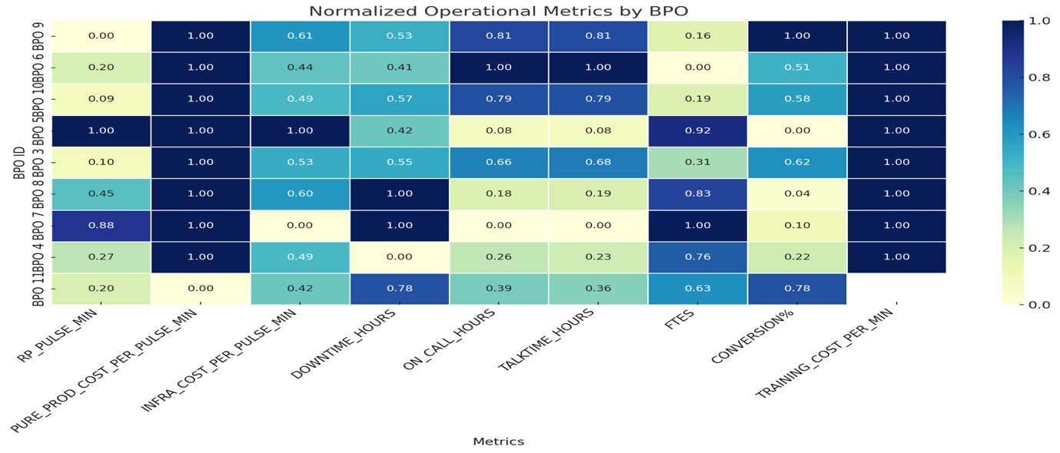

**Vendor Performance Dashboard-**

**Contract Negotiation Strategy-**

The objective is to drive cost efficiencies without compromising on the overall quality. To achieve that various steps should be incorporated-

1. **Strategic Preparation-**

Analyze vendor performance (KPIs) using dashboards like the one I prepared.

Benchmark pricing and Service levels against industry standards.

Align internally on goals and redlines including minimum acceptable SLAs, target cost reductions etc.

1. **Negotiation Levers-**

Volume commitments for discounts guaranteed.

Long-term contracts for better rates (lower unit costs).

Performance-linked penalties/rewards.

Bundle services for cost advantage under a single vendor.

Benchmark clauses to allow rate reviews based on market shifts.

1. **Balancing Cost vs Value-**

Focus on Total Cost of Ownership (TCO) including infrastructure, downtime, training etc.

Reward high-efficiency vendors, not just low cost.

Enforce SLAs with penalties.

Regular vendor performance reviews should be incorporated.

1. **Contract Finalization & Governance-**

Clearly define deliverables, SLAs, and penalties in the contract.

Conduct regular vendor reviews to reassess scope, pricing, and performance.

Include flexible exit clauses to mitigate risks from post-negotiation quality drops.

**Operational Cost Optimization-**

**1. Infrastructure**

Challenge- High Cost due to under utilised infrastructure.

Solutions-

* Consolidate centers
* Use cloud telephony
* Share infra across clients

**2. Workforce Efficiency**

Challenge- labour inefficiencies due to overstaffing or idle time.

Solutions-

* Smart shift planning
* Upskill agents for multi-tasking
* Streamline training

**3. Downtime & Process Waste**

Challenge- downtime impacts revenue and customer experiences.

Solutions-

* Penalize avoidable downtimes
* Automate checks/failovers
* Run lean audits to remove inefficiencies